BVH: Bounding volume hierarchy
( https://cesiumjs.org/2015/08/04/Fast-Hierarchical-Culling/ )
Each node of a tree is associated with a subset of primitives of the objects together with a bounding volume (BV) that encloses this subset with the smallest instance of some specified class of shape.
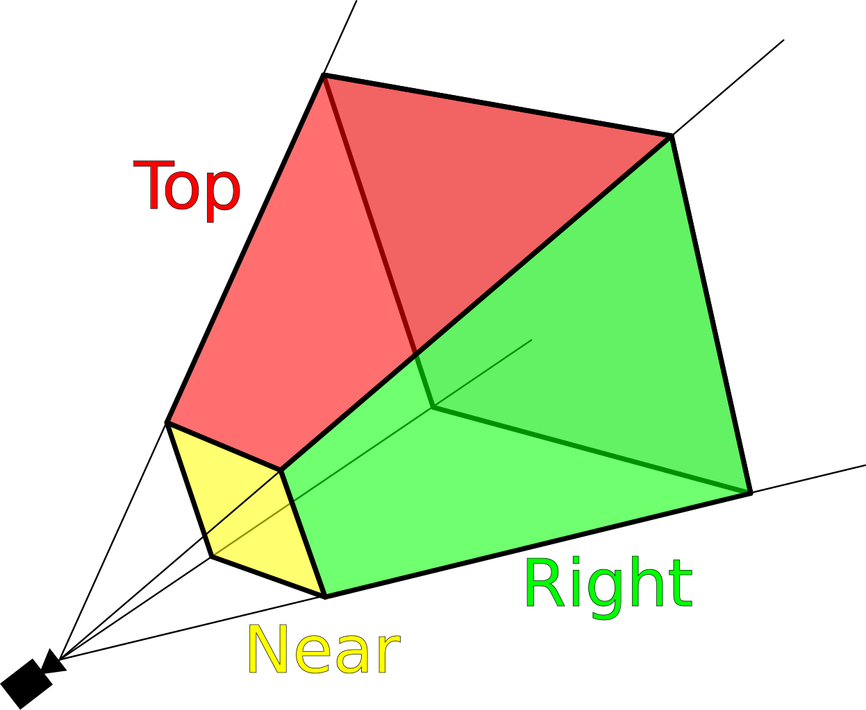
The fundamental point when we call BVH, we check if one of frustum is visible by the camera, in this case we have three possibilities:
- Completely inside
-Completely outside
-Intersecting
In BVH we have saptial relation that mean every object is in relation of parent or child, the structure allow a tree hierarchy.
The request to explore a node is only for the possibility if intersecting with a frustum for that we explore the node to see the child visible in the camera.

Different possibilities and the solution in BVH
Completely inside
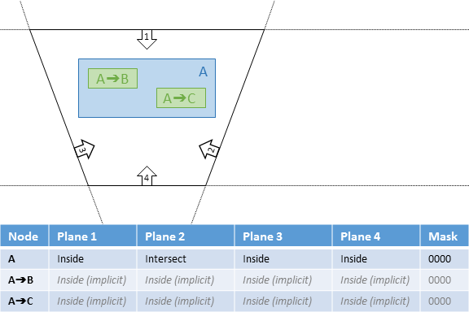
Completely outside
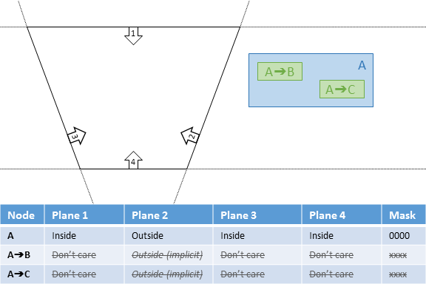
Intersecting
